Measurement Resolution
# Source: AI Source: Provided by: [Data Path: Persons Table -> ID Column: 1, Name_En Column: Motasem Essam] -> From: [ChatGPT] on [7/17/2026]
Measurement Resolution is the smallest change in a measured quantity that a measuring instrument can detect or display. It indicates the instrument's ability to distinguish between two very close measurement values.
A higher resolution allows the instrument to detect smaller differences, resulting in more detailed measurements.

Definition
# Source: AI Source: Provided by: [Data Path: Persons Table -> ID Column: 1, Name_En Column: Motasem Essam] -> From: [ChatGPT] on [7/17/2026]
Measurement Resolution is the smallest increment or change in a measured quantity that an instrument can reliably detect, display, or record.

Purpose
# Source: AI Source: Provided by: [Data Path: Persons Table -> ID Column: 1, Name_En Column: Motasem Essam] -> From: [ChatGPT] on [7/17/2026]
Measurement resolution is used to:
- Determine the smallest measurable change.
- Evaluate an instrument's precision.
- Select the appropriate measuring instrument.
- Improve measurement quality.
- Compare measuring instruments.

Characteristics
# Source: AI Source: Provided by: [Data Path: Persons Table -> ID Column: 1, Name_En Column: Motasem Essam] -> From: [ChatGPT] on [7/17/2026]
Measurement resolution:
- Represents the smallest readable increment.
- Depends on the instrument design.
- Does not necessarily indicate measurement accuracy.
- Usually equals the smallest scale division or digital display increment.

Resolution vs. Accuracy
# Source: AI Source: Provided by: [Data Path: Persons Table -> ID Column: 1, Name_En Column: Motasem Essam] -> From: [ChatGPT] on [7/17/2026]
Resolution and accuracy are different concepts.
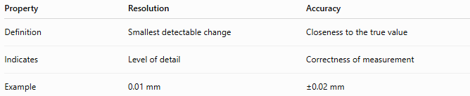
Property | Resolution | Accuracy
Definition | Smallest detectable change | Closeness to the true value
Indicates | Level of detail | Correctness of measurement
Example | 0.01 mm | ±0.02 mm
An instrument may have high resolution but poor accuracy if it is not properly calibrated.

Resolution vs. Precision
# Source: AI Source: Provided by: [Data Path: Persons Table -> ID Column: 1, Name_En Column: Motasem Essam] -> From: [ChatGPT] on [7/17/2026]
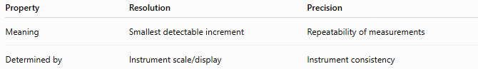
Property | Resolution | Precision
Meaning | Smallest detectable increment | Repeatability of measurements
Determined by | Instrument scale/display | Instrument consistency

Examples
# Source: AI Source: Provided by: [Data Path: Persons Table -> ID Column: 1, Name_En Column: Motasem Essam] -> From: [ChatGPT] on [7/17/2026]
Example 1 – Ruler
A metric ruler is graduated every 1 mm.
Resolution:
1 mm
It cannot directly distinguish between:
- 10.2 mm
- 10.3 mm

Example 2 – Vernier Caliper
Typical resolution:
0.02 mm
It can distinguish between:
- 25.20 mm
- 25.22 mm

Example 3 – Micrometer
Typical resolution:
0.01 mm
High-precision models:
0.001 mm

Example 4 – Digital Balance
Display:
25.678 g
Resolution:
0.001 g

Example 5 – Digital Thermometer
Display:
36.5°C
Resolution:
0.1°C

Formula
# Source: AI Source: Provided by: [Data Path: Persons Table -> ID Column: 1, Name_En Column: Motasem Essam] -> From: [ChatGPT] on [7/17/2026]
For many analog instruments:
$$\boxed{\text{Resolution}=\text{Smallest Scale Division}}$$
For digital instruments:
$$\boxed{\text{Resolution}=\text{Smallest Display Increment}}$$

Typical Resolutions of Common Measuring Instruments
# Source: AI Source: Provided by: [Data Path: Persons Table -> ID Column: 1, Name_En Column: Motasem Essam] -> From: [ChatGPT] on [7/17/2026]
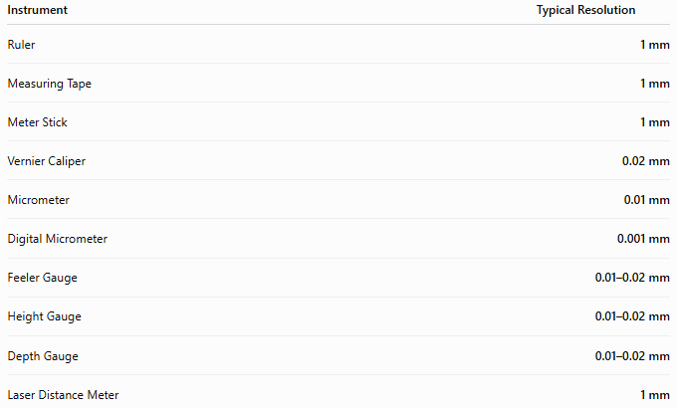
Instrument | Typical Resolution
Ruler | 1 mm
Measuring Tape | 1 mm
Meter Stick | 1 mm
Vernier Caliper | 0.02 mm
Micrometer | 0.01 mm
Digital Micrometer | 0.001 mm
Feeler Gauge | 0.01–0.02 mm
Height Gauge | 0.01–0.02 mm
Depth Gauge | 0.01–0.02 mm
Laser Distance Meter | 1 mm

Importance of Resolution
# Source: AI Source: Provided by: [Data Path: Persons Table -> ID Column: 1, Name_En Column: Motasem Essam] -> From: [ChatGPT] on [7/17/2026]
Good resolution helps:
- Detect small dimensional changes.
- Improve measurement precision.
- Increase manufacturing quality.
- Reduce inspection errors.
- Support scientific research.

Factors Affecting Resolution
# Source: AI Source: Provided by: [Data Path: Persons Table -> ID Column: 1, Name_En Column: Motasem Essam] -> From: [ChatGPT] on [7/17/2026]
Measurement resolution depends on:
- Instrument design
- Scale spacing
- Sensor capability
- Digital display increment
- Manufacturing quality

Applications
# Source: AI Source: Provided by: [Data Path: Persons Table -> ID Column: 1, Name_En Column: Motasem Essam] -> From: [ChatGPT] on [7/17/2026]
Measurement resolution is important in:
- Mechanical engineering
- Manufacturing
- Quality control
- Scientific laboratories
- Metrology
- Electronics
- Aerospace
- Automotive engineering
- Medical devices

Advantages of High Resolution
# Source: AI Source: Provided by: [Data Path: Persons Table -> ID Column: 1, Name_En Column: Motasem Essam] -> From: [ChatGPT] on [7/17/2026]
High resolution allows:
- Detection of very small changes.
- Better inspection capability.
- More detailed measurements.
- Improved process control.
- Greater repeatability.

Limitations
# Source: AI Source: Provided by: [Data Path: Persons Table -> ID Column: 1, Name_En Column: Motasem Essam] -> From: [ChatGPT] on [7/17/2026]
Higher resolution:
- Does not guarantee higher accuracy.
- May increase instrument cost.
- Often requires better calibration.
- May require controlled environmental conditions.

Common Mistakes
# Source: AI Source: Provided by: [Data Path: Persons Table -> ID Column: 1, Name_En Column: Motasem Essam] -> From: [ChatGPT] on [7/17/2026]
- Confusing resolution with accuracy.
- Assuming more decimal places always mean a more accurate measurement.
- Selecting an instrument with unnecessarily high resolution for a simple task.
- Ignoring calibration while relying on a high-resolution display.

Resolution vs. Least Count
# Source: AI Source: Provided by: [Data Path: Persons Table -> ID Column: 1, Name_En Column: Motasem Essam] -> From: [ChatGPT] on [7/17/2026]
For many mechanical measuring instruments, resolution and least count are effectively the same.
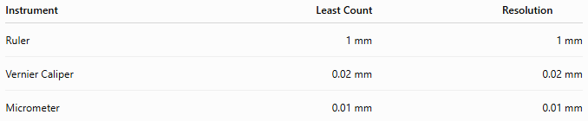
Instrument | Least Count | Resolution
Ruler | 1 mm | 1 mm
Vernier Caliper | 0.02 mm | 0.02 mm
Micrometer | 0.01 mm | 0.01 mm
For some advanced electronic instruments, the display resolution may be finer than the practical measurement capability, so the two values are not always identical.

Key Points
# Source: AI Source: Provided by: [Data Path: Persons Table -> ID Column: 1, Name_En Column: Motasem Essam] -> From: [ChatGPT] on [7/17/2026]
- Measurement Resolution is the smallest detectable change an instrument can measure or display.
- It determines the level of detail in a measurement.
- Higher resolution allows finer distinctions between measurements.
- Resolution is not the same as accuracy.
- Common examples:
  - Ruler: 1 mm
  - Vernier Caliper: 0.02 mm
  - Micrometer: 0.01 mm
  - Digital Micrometer: 0.001 mm

Conclusion
# Source: AI Source: Provided by: [Data Path: Persons Table -> ID Column: 1, Name_En Column: Motasem Essam] -> From: [ChatGPT] on [7/17/2026]
Measurement Resolution describes the smallest increment that a measuring instrument can detect or display, making it a key indicator of the instrument's sensitivity and level of detail. While higher resolution enables finer measurements and improved inspection capabilities, it does not by itself ensure greater accuracy. Understanding measurement resolution helps engineers, technicians, scientists, and inspectors select the most appropriate instrument for a given application and correctly interpret measurement results.

